

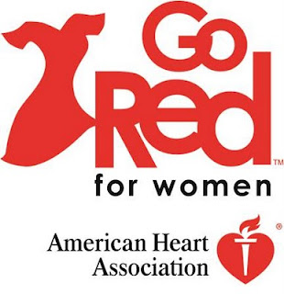

#WearRedandGive

**Take the pledge and wear red!**

**Know Your Numbers!**

Dublin-Laurens Alumnae Chapter

Heart Health Event: Friday, February 2, 2018

11a.m.- 2p.m.

Miller’s Soul Food Café

115 S. Lawrence Street

Dublin, GA 31021

Blood Pressure Screening, Information Booth, & Giveaways

To learn more, including heart healthy tips or to donate, please visit: GoRedForWomen.org